1、identify the concepts

|  |  |  |
| --- | --- | --- |
| Responsibility description | Type | Concept name |
| Can see the daily courses and jump to the editing interface | D | Course display |
| The editing interface is a complete course schedule, click on the corresponding box, you can enter to view detailed course information | D | Course editor |
| Click the box that has not been edited to add a new course | D | Course addition |

2、design sequence diagram

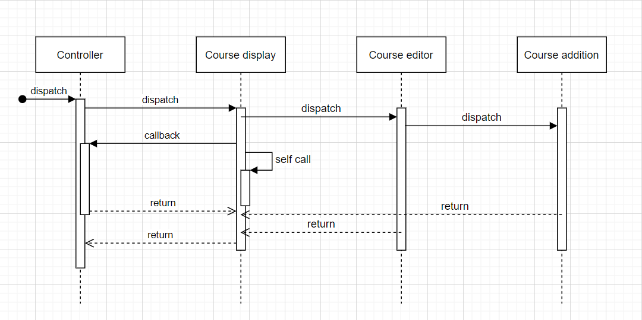

3、class diagram

